After signing in to NNELS you can go to the main page to search the catalogue:
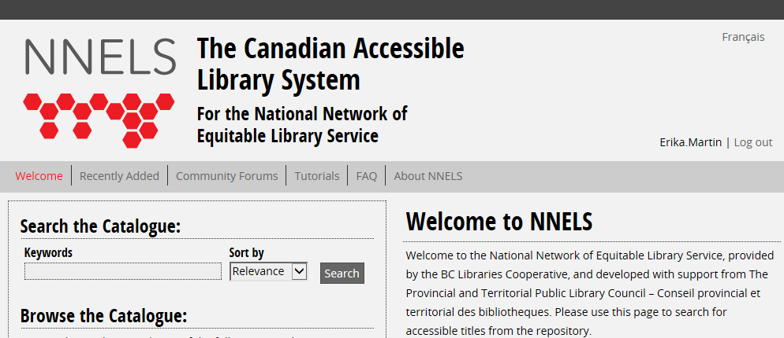
You can either search the catalogue for a specific title, or browse the “Recently Added” section.
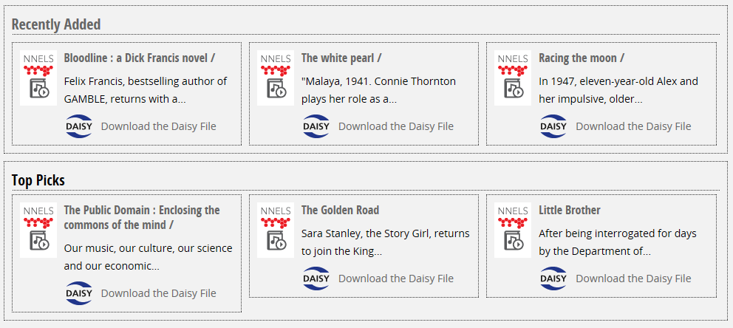
Once you have found the title you wish to download, click on the “Download the Daisy File” button:
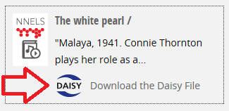
After choosing to download the title you will be asked if you would like to Open, Save or Cancel this selection. Choose Save. The way this pop-up appears on your screen may vary depending on what internet browser is used.
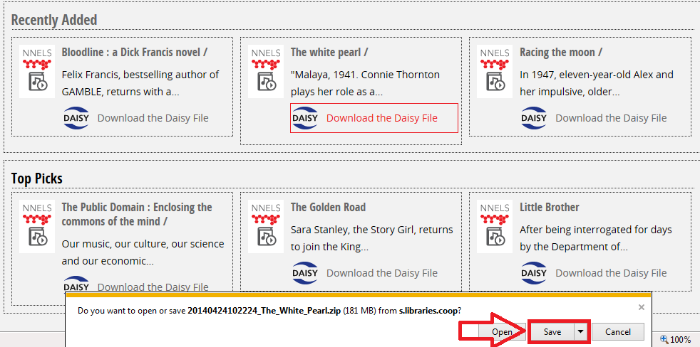
After the download is complete you will need to select “Open Folder,” in order to unzip the file.
After opening the folder you will be able to see the file in the download folder. This file needs to be unzipped. The process for doing this may vary from computer to computer. One way is to use the program WinZip:
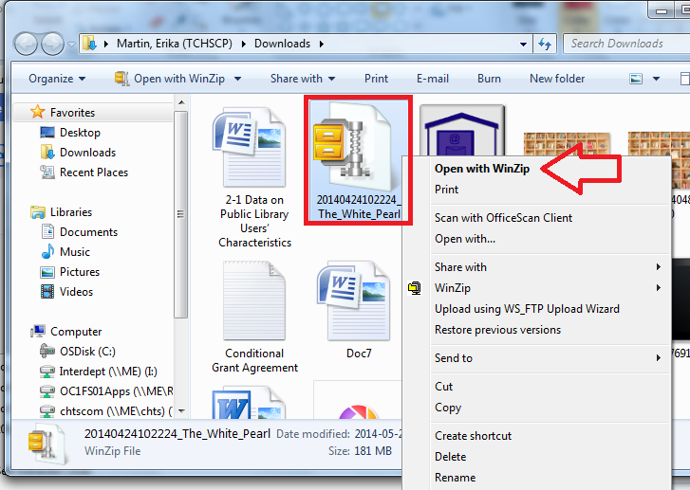
Once in WinZip the file can be unzipped – this makes it available to be burned onto a CD or transferred onto a USB stick.
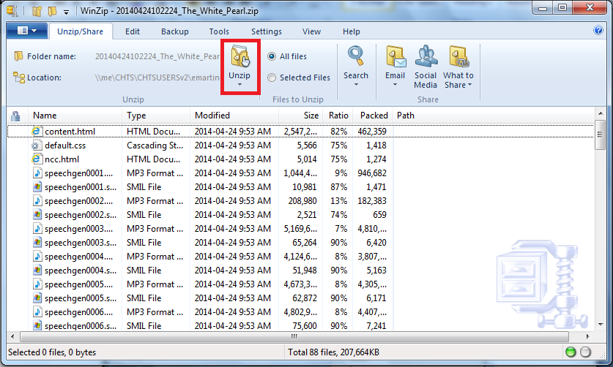

Extracting the files will take a minute or two to load:
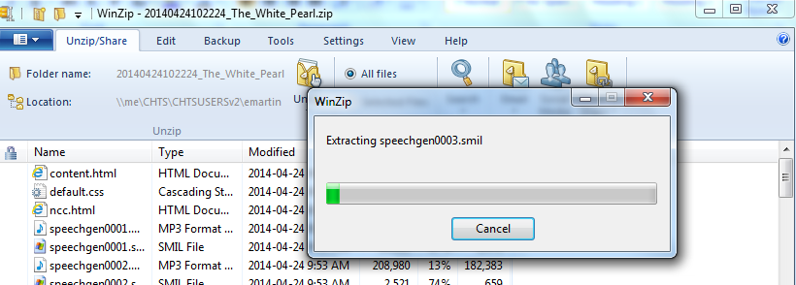
A new folder will come up with the unzipped contents. There will be a button in the upper left-hand side that says, “Burn” – selecting this will allow you to burn the contents of the Daisy book onto a CD.
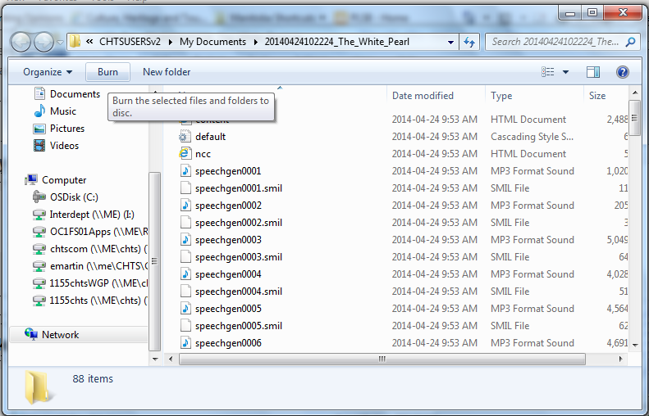
From here you can burn the contents onto a blank CD and provide the copy to your NNELS eligible patron.

